# Test Document for Venue Registration/Login Client

|  |  |  |  |  |
| --- | --- | --- | --- | --- |
| Function Tested | Input | Expected Output | Test Output | Test Result |
| Venue Login  The user puts his username and password and clicks on login. If login is successful, a welcome message appears and the user is redirected to a Shows page where they can add shows | Input a correct username and password | Welcome and Shows.aspx page | Figure 1 | Passed |
| Figure 2 | Passed |
| Input incorrect username or password | Invalid login | Figure 3 | Passed |
| Venue Register  Registering a new venue by entering all the required fields. If successful, the user is redirected to the login page. Else, registration failed message is displayed | Registering successfully | Redirect to login mage | Figure4 | Passed |
| Registering an existing venue | Registration failed | Figure5 | Passed |
| Form Validation test | Clicking register without putting values in the fields | Required fields messages | Figure 6. | Passed |
|  | Invalid email | Invalid email message | Figure 7. | Passed |
|  |  |  |  |  |

Figure 1. Venue login

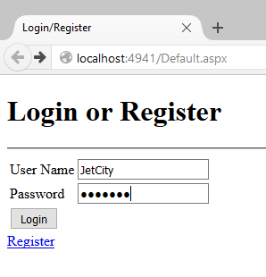

Figure 2. Shows page

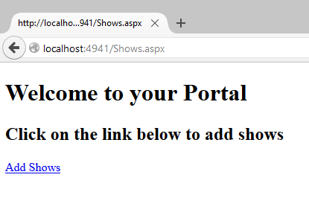

Figure 3. Invalid username and/or password

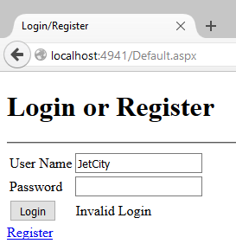

Figure 4. Register success (Redirected to the Login Page)

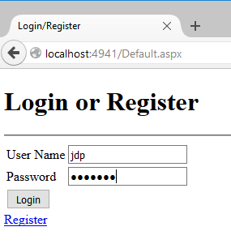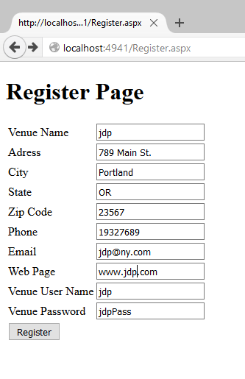

Figure 5. Registering an existing venue

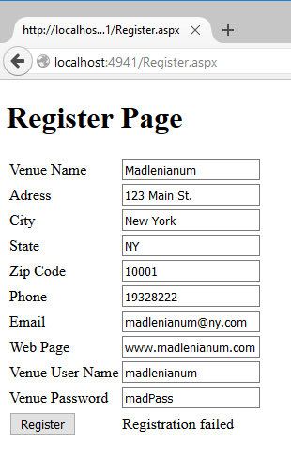

Figure 6. Form Validation Test

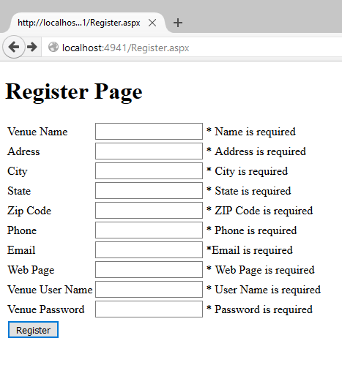

Figure 7. Email Validation

